**Task 1:**

* **Cancer Data**

**Presprocessing :**

1. Dealing with the redundant feature

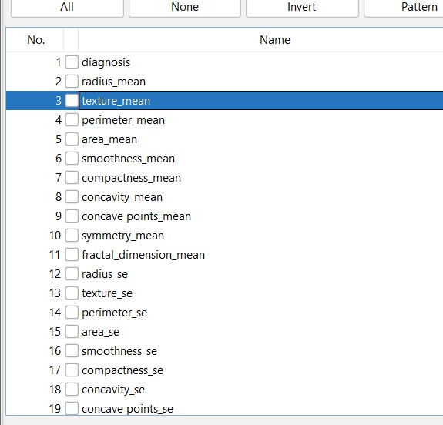

Here we have removed the ID attribute (Column as it was a redundant feature).

1. Dealing with the missing values

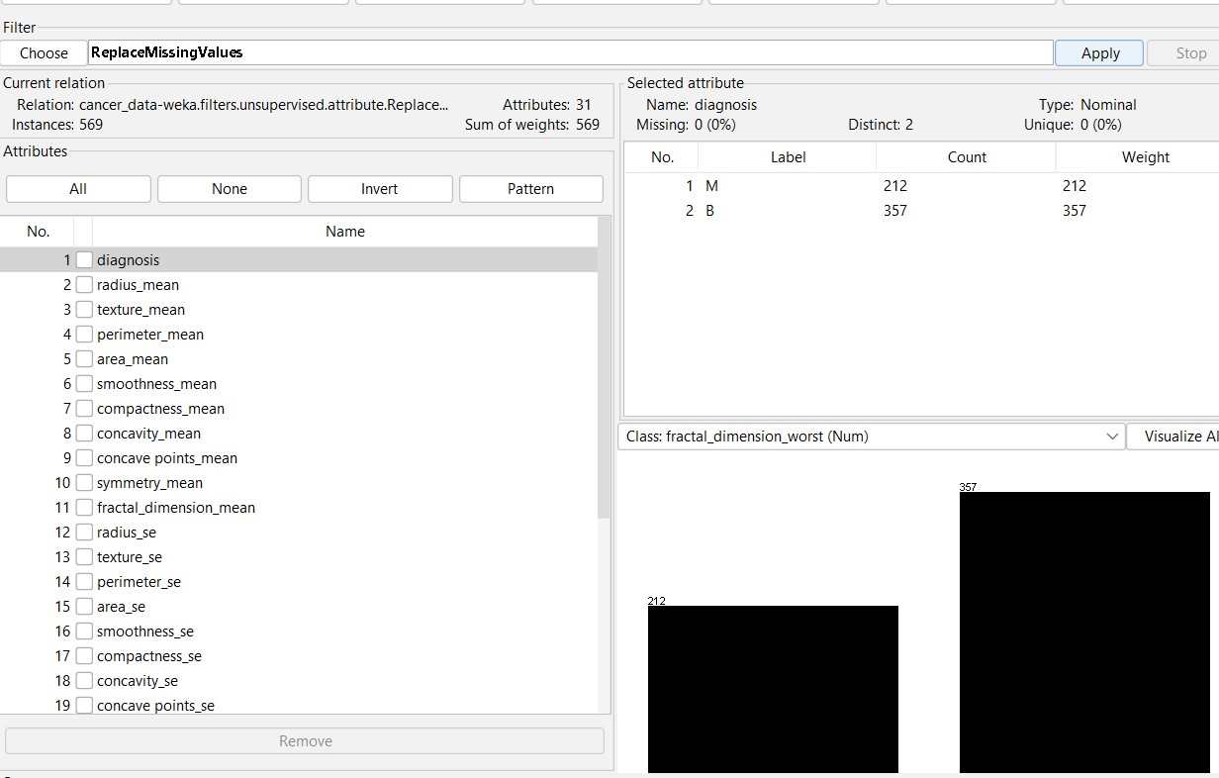

Here we have dealt with the missing values.

1. Normalization:

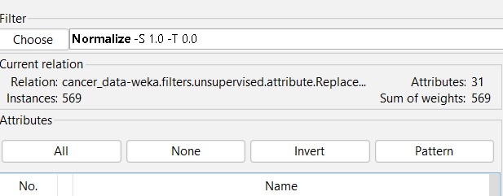

Here we have normalized the complete table. Now our dataset is completely preprocessed.

Now Apply PCA

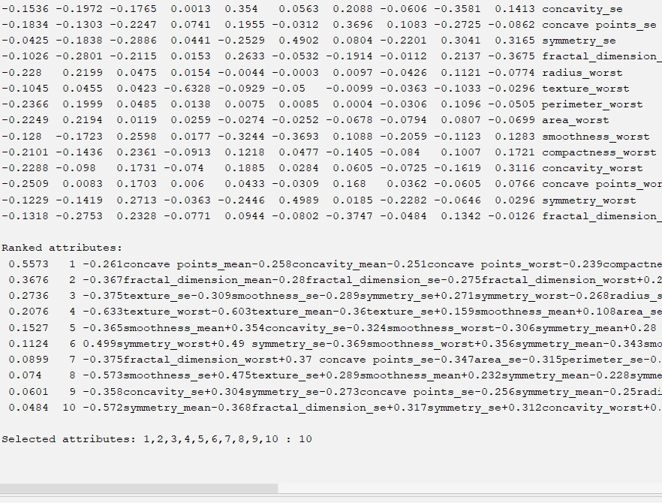

Now Apply all the Classifications

1. Decision trees

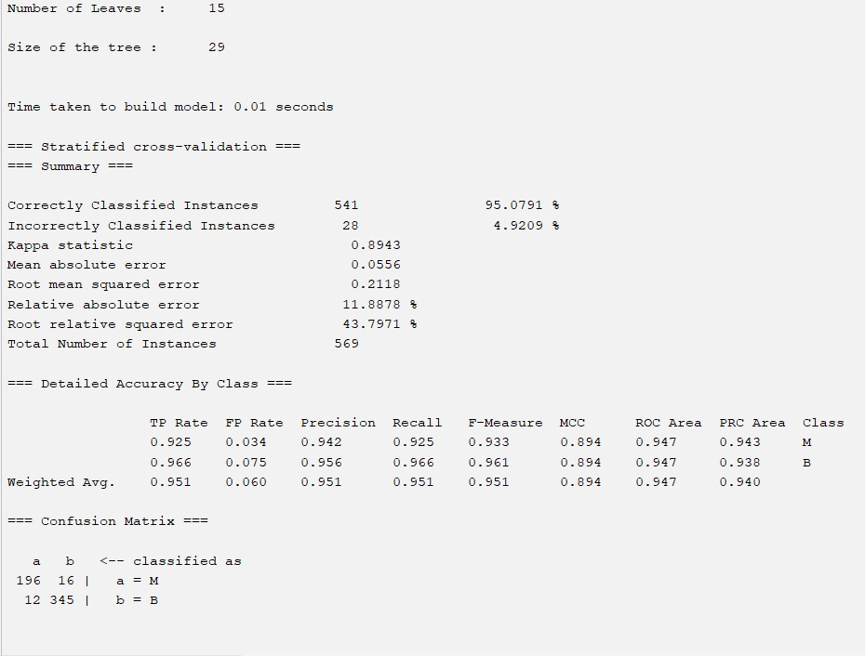

1. Random Forest

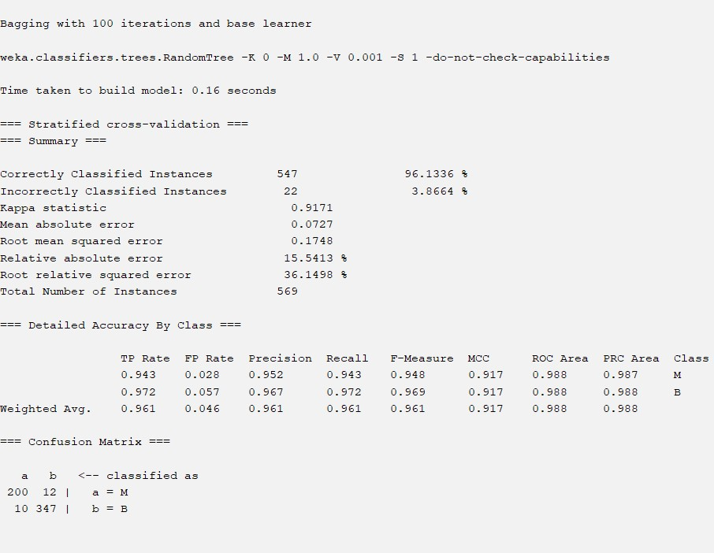

1. Naïve Bayes

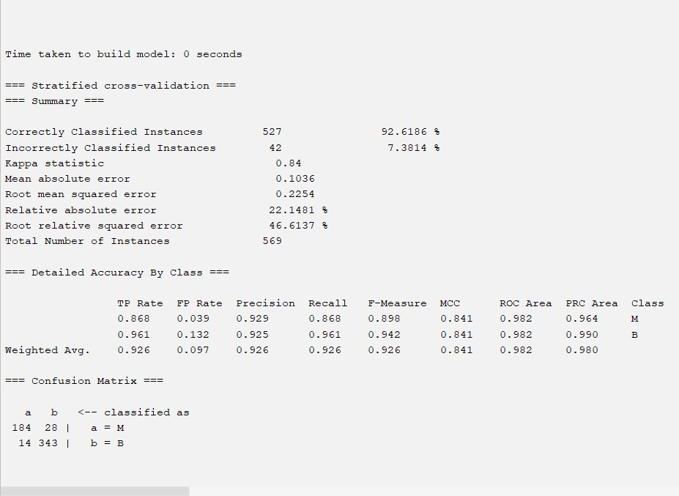

***Result:***

***The accuracies were improved of all the classifiers.***

* **Diabetes Data**

1. Replacing the null values

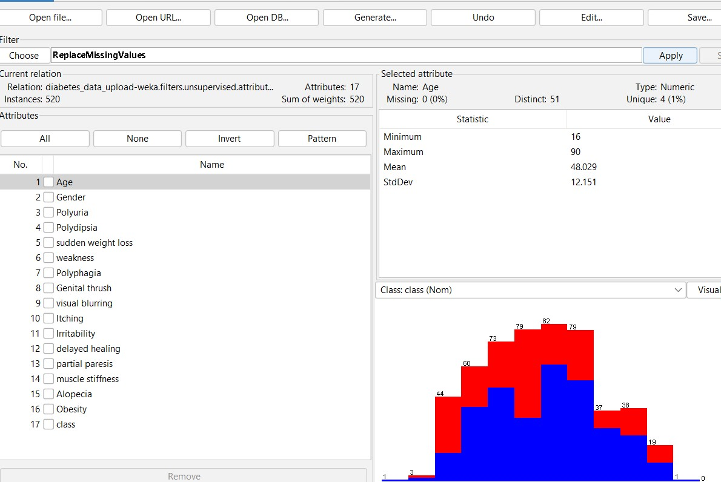

Normalization:

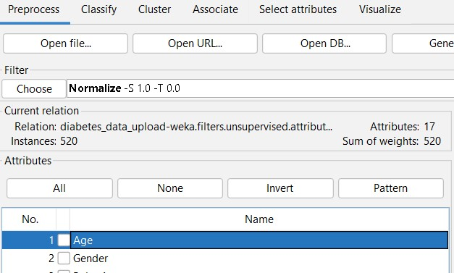

Now we will be applying the Classifications methods on the dataset

**PCA:**

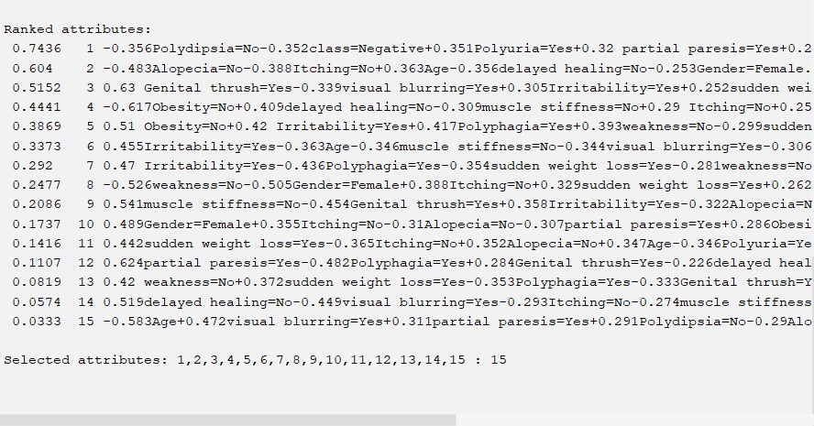

**Classification:**

1. **Decision Tree**

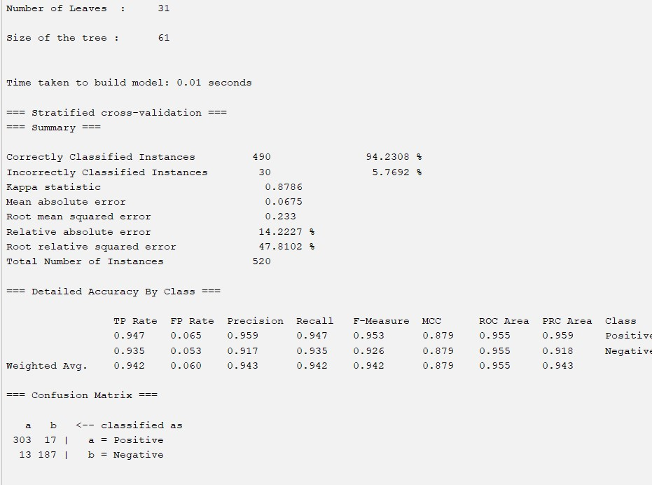

1. **Random Forest**

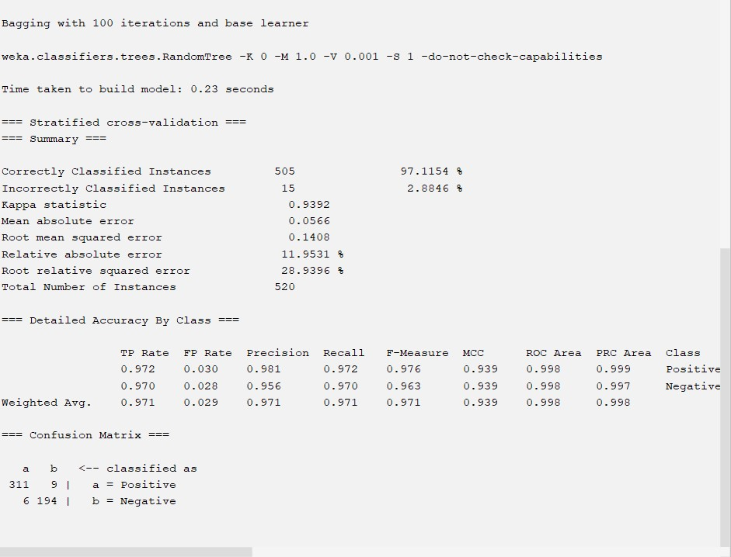

1. **Naïve Bayes:**

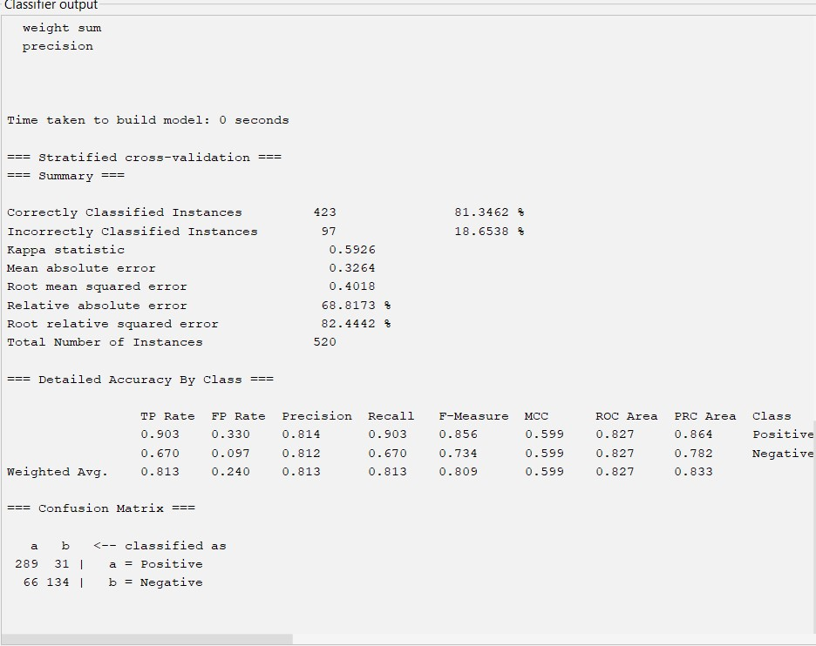

**Result:**

Based on the above results, we can conclude that

1. Random Forest is best for classification in this case with 97.17% Accuracy
2. Decision tree is good for classification in this case with 94% Accuracy
3. Naïve Bayes is OK for classification in this case with 81 % Accuracy